# Statistical Machine Learning – Project Part 3

**Classification (Using Neural Networks and Deep Learning)**

**Dataset Used:**

The dataset used is the MNIST handwritten digits dataset. The dataset is available in Keras dataset list. As given, the training is done on 50,000 images and testing on 10,000 images. The size of each image is 28 X 28.

**Objective:**

The objective of the project is to build a convolution neural network in Keras using the Google CoLab platform and train the model using the given dataset.

The code provided was for a two-layer CNN with kernel size of 3X3 and 6 feature maps for the first layer and 16 for the second layer. For the project, the code was run for three different configurations.

* The first configuration was the original configuration as specified above.
* The second one was increasing the kernel size to 5 X 5 and running the model.
* The third on involved changing the value of the feature maps for the two CNN layers before running the model.

After running the model for all scenarios, the testing accuracy and the testing loss was recorded for all cases. Also, two graphs were made for each case. The first chart was a line plot between the training loss values and the number of epochs. The second chart was another line plot between the validation loss values and the number of epochs. These values were analyzed to better understand the impact of these parameters in the models.

**Result:**

These are the results for each of the configurations used for the CNN. The code for each configuration is provided as separate files.

* Config 1 - 3 x 3 kernal size; Feature maps: 6 for first layer and 16 for second layer
  + Test Loss: 6.92%
  + Test accuracy: 97.78%
  + `Graphs:

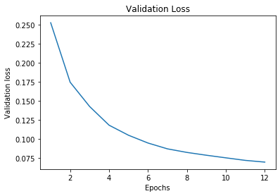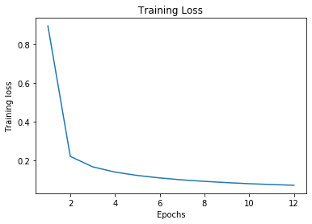

* Config 2 - 5 x 5 kernal size; Feature maps: 6 for first layer and 16 for second layer
  + Test Loss: 6.38%
  + Test accuracy: 98.06%
  + 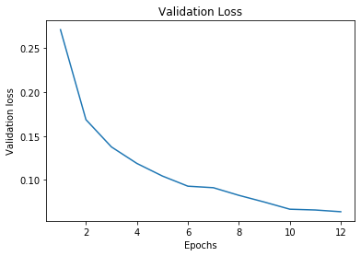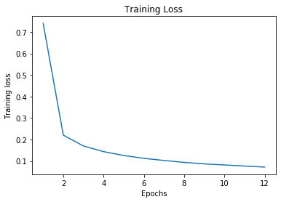Graphs:
* Config 3 - 3 x 3 kernal size; Feature maps: 4 for first layer and 12 for second layer
  + Test Loss: 7.18%
  + Test accuracy: 97.77%
  + Graphs:

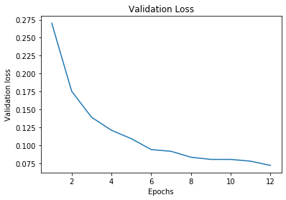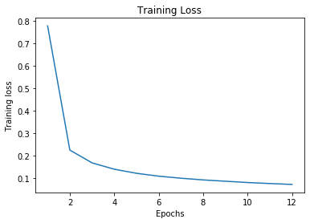

**Conclusion:**

In this project, a model was created using Convolution Neural Networks and run on the MNIST handwritten digit training set. The model was run using three different configurations and the results were recorded and plotted to understand the behavior. The results were largely similar with very little difference in the final values or in the plots.